LAB NO# (06)

- LAB TITTLE:
“TO PRINT THE PROGRAM THAT SHOWS THE NUMBER IS EVEN OR ODD USING CONTROL STATEMENTS IF &IF ELSE AND PRINT THE GRADING SYTEM USING THESE STATEMENT”.
- OBJECTIVE:

PRITNT THE PROGRAM THAT SHOWS NUMBER IS EVEN OR ODD AND GRADING SYSTEM OF YOUR SUBJECT.
- TOOLS:
CODE BLOCKS SOFTWARE:
- PROCEDURE:

- First of all open the jupyter Notebook software in your Pc/Laptop.
- Then create a new project in pythan and save in some folder.
- Then start typing your program that you want to type.
- To print a print a program that shows that number is even or odd we use control statements if or if else.
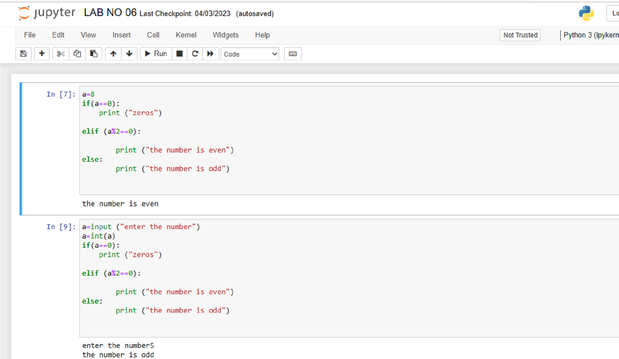

5. Now if you want to print the grading system that you enter you enter your marks and its show your grade.

EXAMPLE

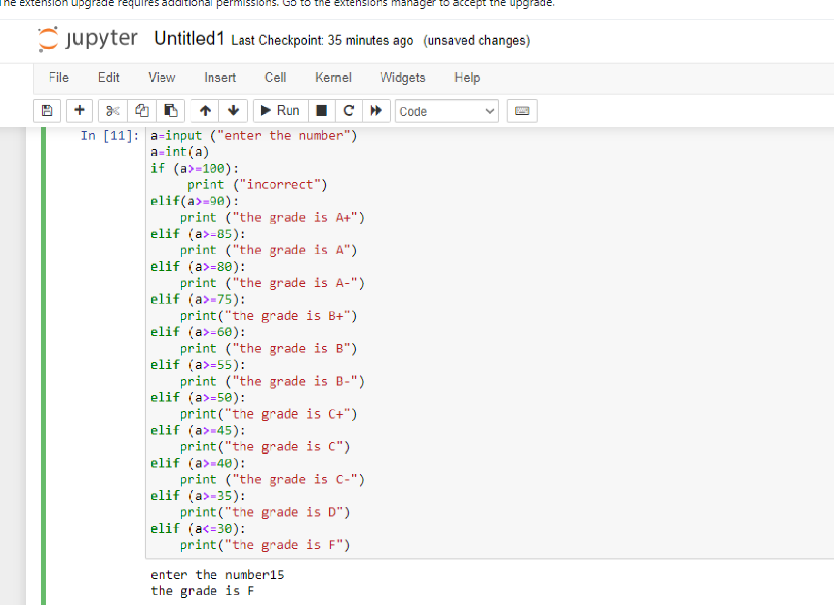
we are familiar with or observed that how to print the even
OBSERVATION
and odd number and how to print the grading system

